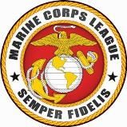
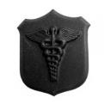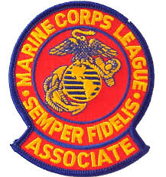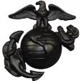

*** JULY 2018 NEWSLETTER ***

Our next meeting will be on: 18 July 2018
_____________________________________________

50th Year Reunion of the
1968 All Oregon Platoon #1018

Emerald Empire Detachment member Dan Stombaugh was one of a few original members who helped plan and coordinate a reunion of his Oregon Platoon #1018, United States Marine Corps Boot Camp, Marine Corps Recruit Depot, San Diego, California. All of the members of this platoon were enlisted from the State of Oregon.

Dan Stombaugh was instrumental in the efforts to get this reunion recognized by the State of Oregon. As such, the Governor of Oregon signed a “State of Oregon, Proclamation, Office of the Governor,” proclaiming 7 June 2018 as ALL OREGON PLATOON DAY.

Outstanding work as always Dan Stombaugh!
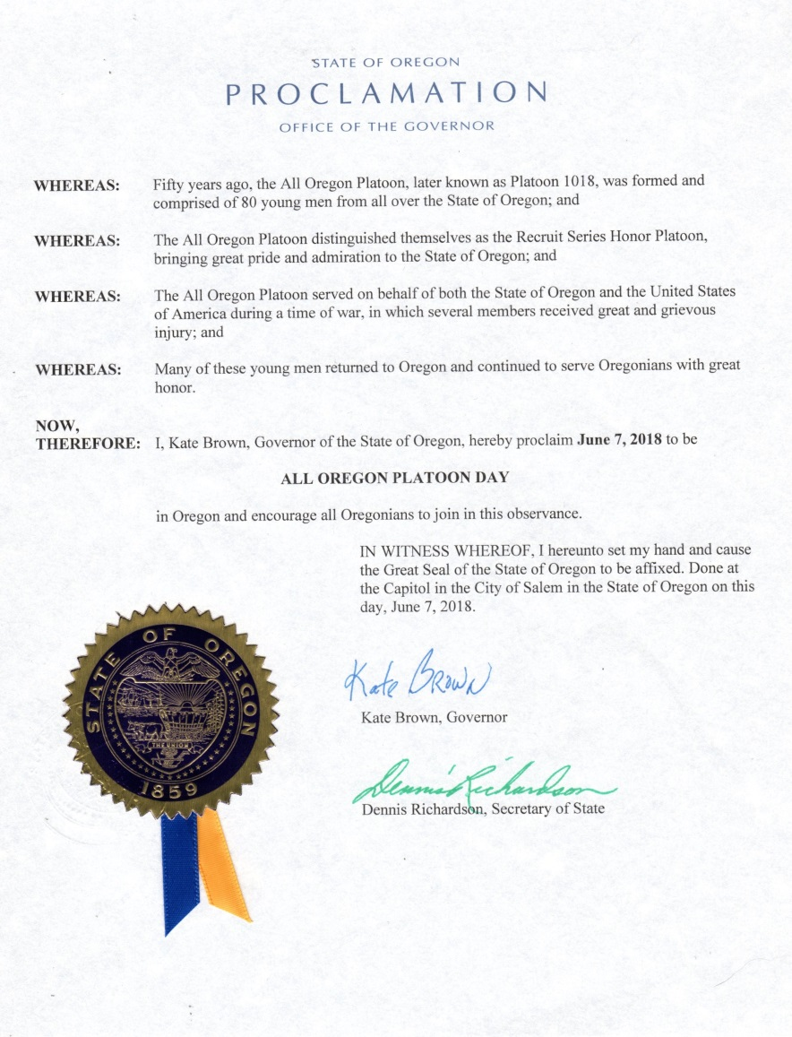

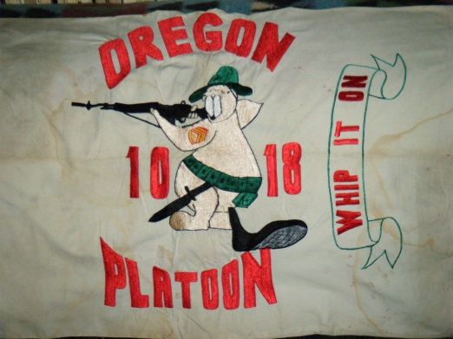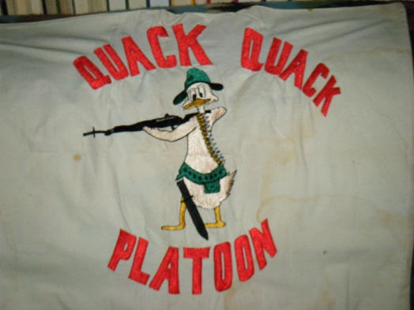

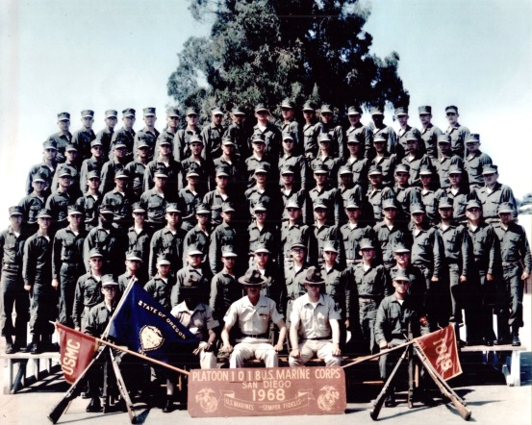
THEN (1968)
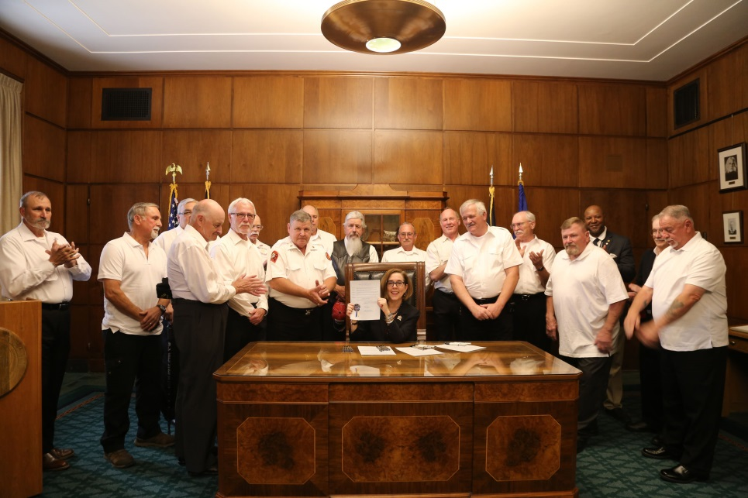
AND NOW (2018)
The two standing next to the Governor: I wonder if they may look familiar to you????

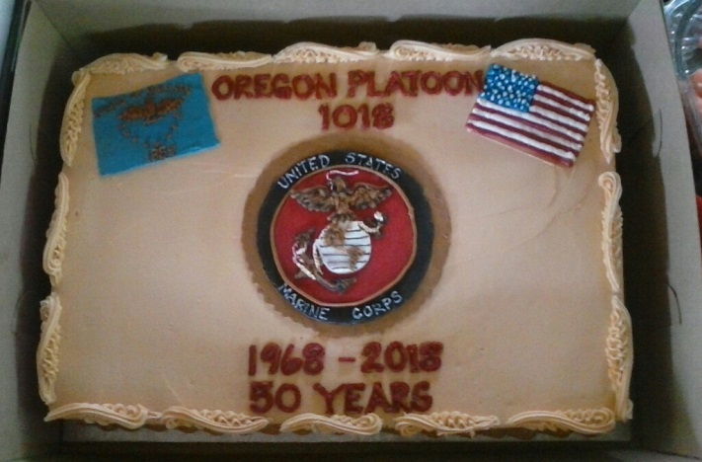

------------------------------------------------------------------------------------------------------------------------------------------------------------------------------------------

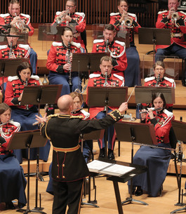

The President’s Own
United States Marine Band

Prior to the June 2018 meeting we received the following email from Holly Spencer:
Hello!
I’m writing to ask if you’d be interested in helping arrange a concert here by the President’s Own as they tour the west coast in October 2019. My son is a member of this prestigious band, and has given me information about the last time they came to Eugene 9 years ago. The Marine Corps League was the main sponsor!

I am now the executive director of the nonprofit organization, the Eugene-Springfield Youth Orchestras, and I would really love to make this happen. My son, Staff Sgt. Lewis Gilmore, graduated from South Eugene High and was a member of our orchestras. He is sure that this would be a very welcome event in our area.

I am very excited about the idea, as the band is always extremely popular wherever they go. I believe the Silva concert hall in the Hult Center would be the best venue (and was the venue last time), as it holds the most people as far as I know.
There are guidelines, etc., which you are probably aware of. We would of course need sponsors to pay for the hall, marketing, etc. And we would need to involve the city of Eugene for security.

I would be very glad to meet with you about this if you are interested. I am willing to find sponsors, meet with people, and help in any way I can. Please let me know if you would like to continue this conversation!

Thank you!
Holly

Holly Spencer, Executive Director
Eugene-Springfield Youth Orchestras (ESYO)
PO Box 5666, Eugene OR 97405
541-484-0473 cell: 541-554-7165
https://www.facebook.com/ESYOrchestras/
http://esyorchestras.org/

Holly was invited to come and give a presentation at the June meeting. Holly has many contacts already established with her position with the Youth Orchestras, but was somewhat taken back by the initial estimate of costs to rent the Silva Concert Hall.

Thad Lukasik and Mike Barker 9 years ago undertook the operation of working out bringing the United States Marine Band to the Silva Concert Hall. Thad and Mike have a wealth of knowledge and will sit down with Holly to combine their knowledge with Holly’s experience and contacts.

We will have a discussion at the 18 July 2018 monthly meeting regarding the feasibility of SPONSORING the United States Marine Band.

SPONSORING the band will require the involvement of all the members. There are too many details to cover in this newsletter so come to the JULY meeting and be a part of the discussion. We cannot rely on only a few members to undertake an operation of this size and responsibility.

But also think of how we could get the Marine Corps League name and image out to so many.
-------------------------------------------------------------------------

MARINE CORPS LEAGUE GOOD CITIZENSHIP AWARD (EAGLE SCOUT):

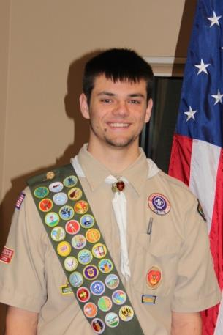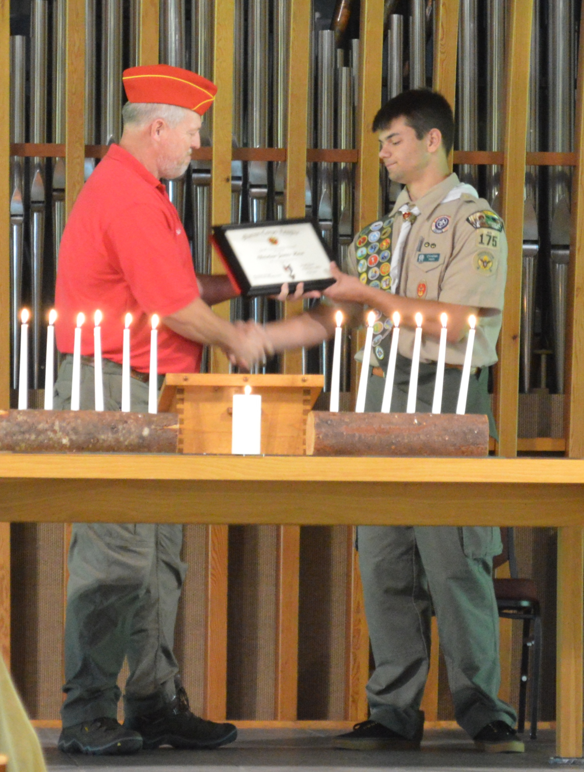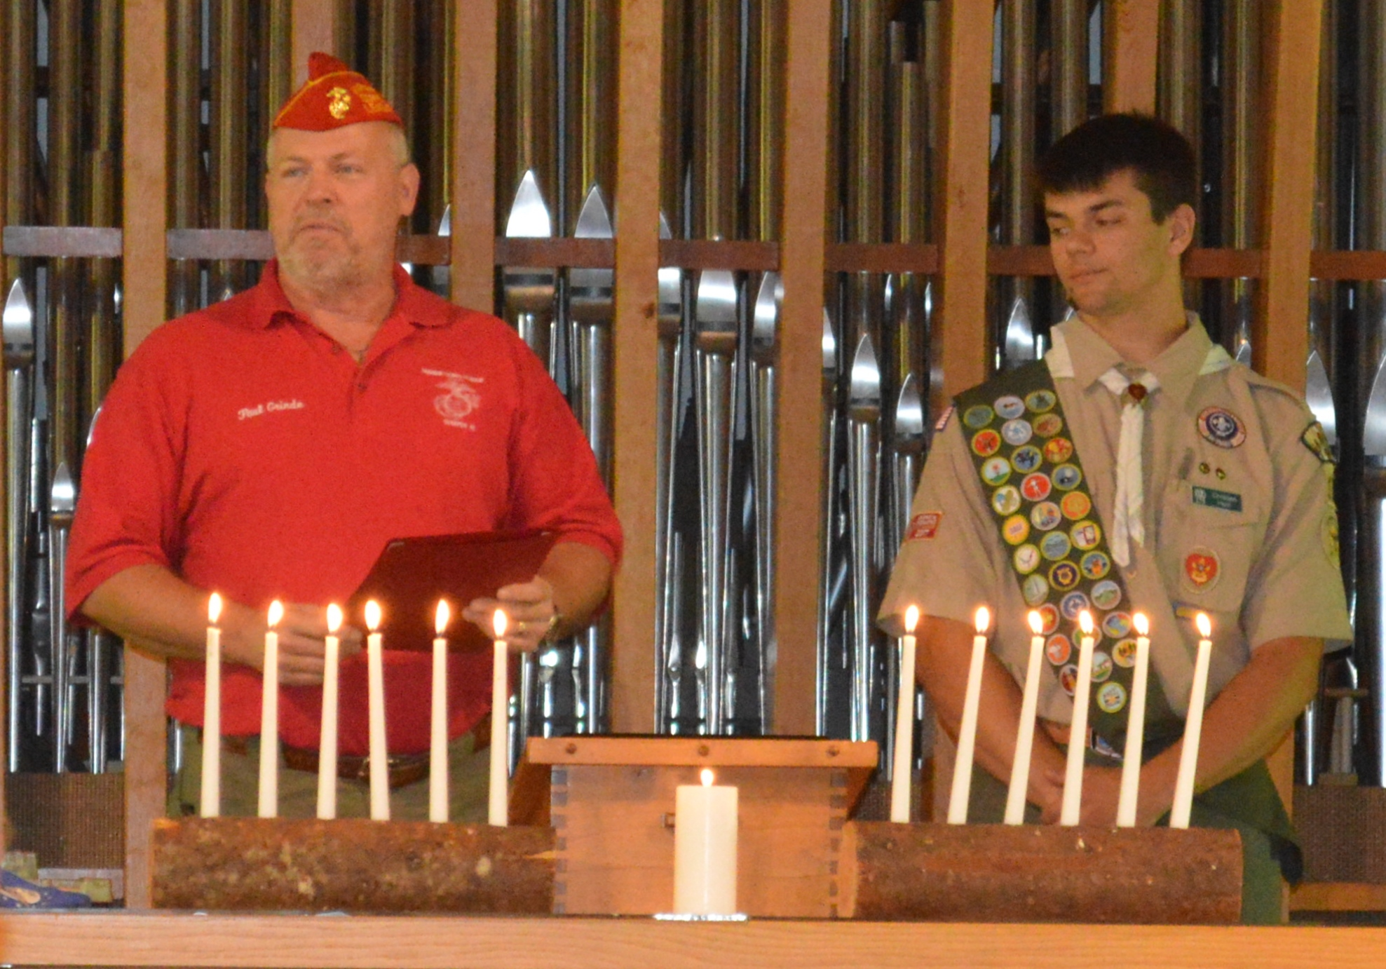

On Saturday 23 June 2018, at 1:30 PM, Senior Vice-Commandant Paul Grinde attended the Eagle Court of Honor for Christian James Horn. The presentation was made at the Westminster Presbyterian Church, Eugene, Oregon.
Christian is the son of Michael and Nancy Horn. Christian started scouting at the age of 6 years old, and by age 18 he had completed the requirements for Eagle Scout. Christian is a member of the Boy Scouts of America, Troop 175.

Eagle Project description:
Christian’s Eagle Scout project took place at Camp Harlow, an extension of 1st Baptist Church in Eugene, OR. He organized a crew of 25 Scouts and Adult Leaders to install (33) concrete bollards around the HVAC units at all of the boys and girls cabins to protect the units from potential damage due to large equipment that may come into contact with the units. Christian met with the Project Coordinator from Camp Harlow on a few occasions. He prepared the site with the necessary equipment to dig level and secure the bollards, arranged for pickup/delivery of gravel; wheelbarrow’s, shovels/tampers, and lunches. He identified the areas underground that were safe or not safe to dig and scheduled prep days to have Scouts mark those areas accordingly. In addition he held a prep day for a small crew to install a portion of the bollards to be prepared for the entire crew the next day.

Christian earned 31 Merit Badges as a Boy Scout, ten more than what is required for an Eagle Scout. The additional ten Merit Badges earned Christian 2 Eagle Palms (one bronze and one gold). The gold palm being the higher award is the one displayed on the Eagle Scout Badge.

Christian becomes the 26th Marine Corps League Good Citizenship Award presented by Emerald Empire Detachment #917, Department of Oregon, Marine Corps League.

----------------------------------------------------------------------------------------------------------------------------

CHAPLAIN / CORPSMAN:

Nancy Lukasik – Nancy reported that her brother Gerald was diagnosed with Congestive Heart Failure. Gerald had purchased the “scooter” we received from Jess Wise’s estate two yard sales ago. Nancy reported that Gerald really appreciated getting the scooter and that it really helped him in getting around. It sounds like Gerald is committed to following his doctor’s advice in addressing this diagnosis, and so much so that Gerald also bought a Harley motorcycle. Gerald is an Army veteran who served in Europe.

Please keep Nancy, and Gerald, in your thoughts and prayers.
-------------------------------------------------------------------------------------------------------

Thadd & Courtney Pooler – I received and previously forwarded the following email from Thadd Pooler (SSgt USMC Retired): Hope everything is going great for you guys. Wanted to give you an update on what’s going on here in Utah. Courtney graduates from school in August. After that she than goes to the state board and takes her licensing tests. At that point she is licensed to cut hair, nails, and hair extensions. On July 16 we go down to Arizona to finish the IVF process. The doc is going to implant the one fertile embryo that was retrieved back in April. Two week later we go to our local doc to see if it took, and at that point she will be pregnant. I decided I needed to do something. Retirement was boring me so I found a part time job working for Weber County Park Service. I’ll be mentoring and keeping high school kids on task to work. I start this job on Wednesday. Hope you have a great day. Tell all the Marines hi for us and we miss you all. Yes even Thad.

Semper Fi
Thadd

Please keep Thadd and Courtney in your thoughts and prayers as they move forward in new jobs and careers; and especially as they continue through the process to become “pregnant.”
-------------------------------------------------------------------------------------------------------------

Chuck Lang - I received a text from Chuck Lang advising that he will be having additional surgery on 19 June 2018. This surgery will be to clear the femoral artery on his left side.

If you feel inclined please send him a text at 1-360-219-6826. This is the most direct way to contact Chuck. Or give him a call at the same number.

Please keep Chuck in your thoughts and prayers as he recuperates from this delicate surgery.

-----------------------------------------------------------------------------------------------
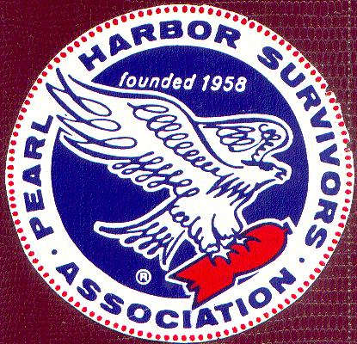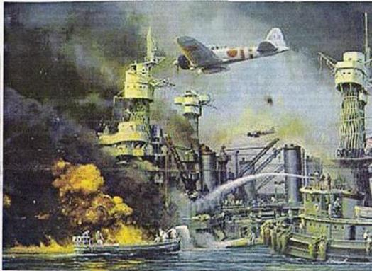
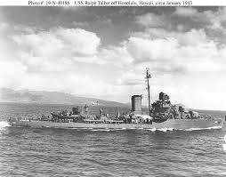
US Navy Ship DD390 Rob Talbot
{USS Ralph Talbot (DD-390) was a Bagley-class destroyer in the United States Navy, named for USMC Second Lieutenant Ralph Talbot, who was awarded the Medal of Honor during World War I.}

Local Pearl Harbor Survivor Plans to Attend 77th Anniversary Remembrance
Tex Estes – is a 44 year member of the Springfield ELKS Lodge. Tex is also a U.S. Navy veteran who was serving aboard the Destroyer USS Ralph Talbot (DD-390) the morning of December 7th, 1941.
Tex has never been back to Pearl Harbor as part of the Anniversary Remembrance. Rick Armosino has had some discussions with Tex and following these discussions Tex decided he would like to attend this year. Rick Armosino provided a briefing to the detachment members before the start of the May monthly meeting. Rick is the Chairman overseeing the planning and raising of funds to get Tex on a Special Honor Flight to Pearl Harbor along with accommodations. The plan is to fly Tex (with Rick as his attendant / escort) to Hawaii on 5 Dec 2018, attend the Ceremony on 7 Dec 2018, and return home on 8 December 2018.
Rick informed the group that Tex will be receiving a “Special Invitation” from the U.S. Navy to attend the ceremony, and that Tex will be “Reserved a Place of Honor” during the ceremony.
Tex is 94 years of age.
This is not a traditional “Honor Flight” so all of the costs for flights and accommodations need to be covered.

Donations to cover costs should be made to:
Elks Lodge 2145
(Attention: Tex Estes Honor Flight)
1701 Centennial Blvd, Springfield, OR 97477
(541) 747-2145

According to Rick any excess funds will be donated to the Honor Flight organization.

-----------------------------------------------------------------------------------------------

Emerald Empire Detachment Officer’s
The elections for the elected positions (Commandant, Senior Vice-Commandant, Junior Vice-Commandant, and Judge Advocate) were conducted during the June 2018 monthly meeting. The newly elected officers are:

Commandant
Dave Huber

Senior Vice-Commandant
Peter Bock

Junior Vice-Commandant
Steve Price

Judge Advocate
Robert Shirley

Please give your newly elected Detachment Officers your full support, and plan to attend the Installation Ceremony during the July monthly meeting.

Installation of Officers to occur during the July month meeting (18 July 2018)

Detachment Officer’s information at the end of the newsletter will be updated following the Installation Ceremony (see look for the August Newsletter).

-------------------------------------------------------------------------------------------------------------------------------
Emerald Empire Detachment 2018 Fund Raising Yard Sale

On Thursday 7 June 2018, members Craig & Kelli Myers, Ray & Linda Myers, Thad & Nancy Lukasik and Paul Grinde met at My-Comm and did most of the yard sale set-up. Craig & Kelli also fed us by providing grilled hot dogs and tea.

Friday morning Craig and Paul loaded up a trailer full of donated furniture coming from Craig and Kelli’s son and daughter-in-law’s new home. By the time Craig and Paul arrived back at the yard sale location (My-COMM, Inc. business location) there had already been people arriving and the sale was underway. Mike & Debbie Barker also attended and brought donations. Dan Stombaugh arrived from Portland and brought some more donations. Ray & Linda Miller also attended. Craig & Kelli again provided grilled hot dogs, brats and tea. Joy Cavin brought homemade banana bread, chocolate cupcakes, and hot coffee. Amy Grinde arrived about noon and brought Voodoo Donuts to share. Even though the clouds were dark at times, and it rained some, we did a pretty steady business. Some noted a drop in the temperature.
Saturday the majority of the rain had fallen during the night, and the day was not too bad weather wise. We enjoyed another pretty steady day. We also received some more donations from Craig & Kelli’s son-in-law and daughter.
Sunday was a little slower but we still had a fair amount of people and purchases. We closed down Sunday afternoon and felt for the 3 days and with the weather we were closing in on last year’s total amount.

The amount we made this year:
Friday $645.70
Saturday $635.05
Sunday $308.50
Total deposited $1,589.25.
Money Owed Young Marines: $15.00
Net Total: $1,574.25 (over 3 days, high visibility, advertising {paper & craigslist Eugene}, damp, cooler, wetter weather)

Last year we took in: $1,785.26 (over 4 days, high visibility, no advertising, and with much dryer / warmer weather)

Difference between last year and this year: $211.01

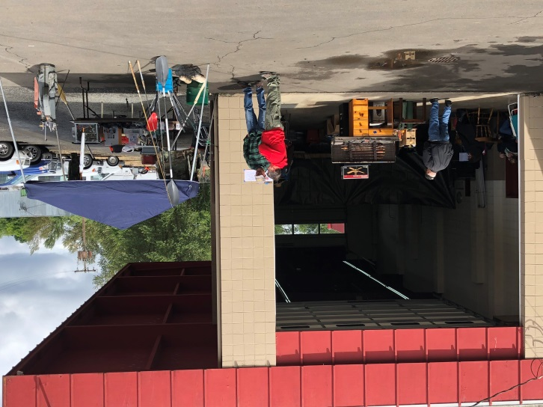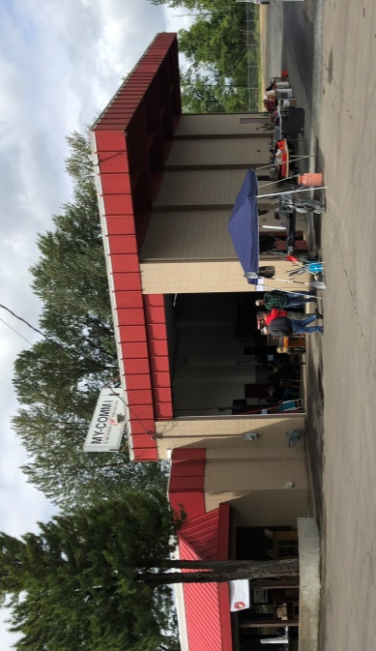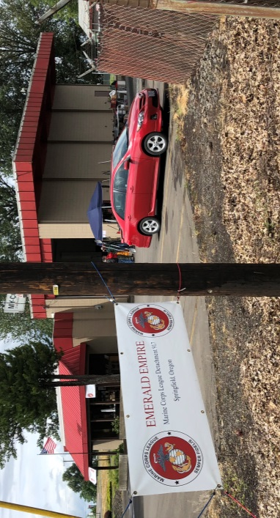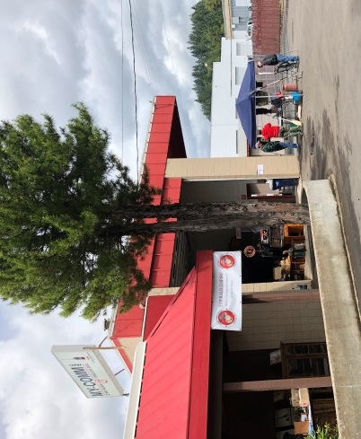

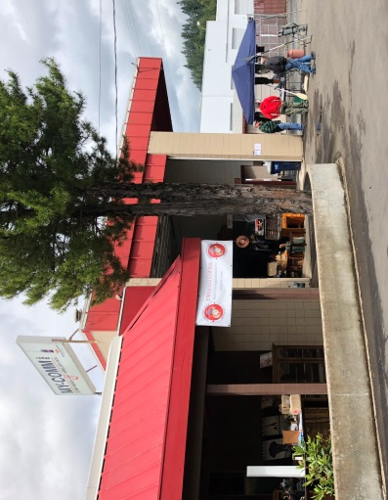

(I was so busy during the Friday and Saturday portion of the sale that I neglected to take photos. These are from Sunday when things were a little slower.)

We must express our great appreciation to Craig & Kelli Myers for once again hosting our yard sale at their MY-COMM, Inc. business location and providing with drink and grilled food. Extra appreciation must be expressed since we were actually using their location when they were open and running their business on Friday. They went above and beyond to host us. Please give them your most sincere appreciation when you see them.
---------------------------------------------------------------------------------------------------------------------------------------
GOOD OF THE LEAGUE ANNOUNCEMENTS
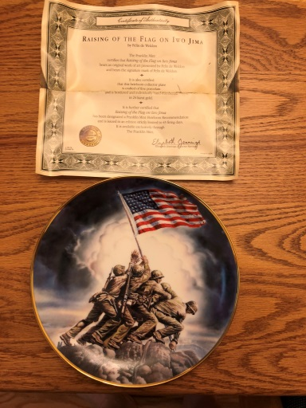
- SPECIAL RAFFLE to occur at July 2018 Monthly Meeting

A Limited Edition of the “Raising of the Flag on Iwo Jima,” by Felix de Weldon, Plate No: G7616 and produced by The Franklin Mint will be the Special 50-50 Raffle Item.

-----------------------------------------------------------------------------------------------------
- During the June meeting a motion was made, seconded and passed that the Emerald Empire Detachment make a donation of $100.00 toward the Tex Estes Honor Flight project mentioned earlier in this newsletter.
----------------------------------------------------------------------------------------------------
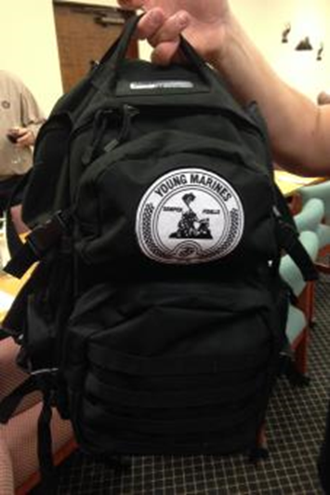
- The Young Marines raised $160.00 during the Detachment Yard Sale. The funds were raised by selling the old ALICE packs {they used to use prior to buying the new type of backpacks previously reported in April 2018 newsletter}; selling old camo pants/tops; and giving away beef sticks {close to expired} for a donation. An old camo field jacket was also sold and that money ended up in the Young Marines Escrow for our detachment and will be presented to the Young Marines at a future date.

________________________________________________________
- Ron Cooper, Sr. – reported that he personally distributed forty (40) 3” X 5” flag sets to Vet’s Court and Veterans Legacy personnel. Ron also presents each graduate of Vet’s Court with a 12” X 18” American Flag.
Outstanding work Ron!!!
____________________________
- Ron Cooper, Sr. & Joseph Lamm are going to prepare two small scale models / examples of memorial ideas for remembering our deceased members. When completed we will go through the City of Springfield to arrange a meeting with the Springfield Veteran’s Memorial Plaza owners (Willamalane). We will see it they will allow us to install this memorial in the plaza area.
- ------------------------------------------------------------------------------------------------------
!!!!!!!! !!!!!!!!

MEDIA ADVISORY

ATTENTION ALL VETERANS, FAMILY MEMBERS, AND STAKEHOLDERS

Roseburg VA Healthcare System (RVAHCS) schedules Town Hall in

Eugene, Oregon
RVAHCS Veterans Town Hall
July 12, 2018
5:00 pm to 7:00 pm
Eugene VA Health Care Center Front Lobby, 3355 Chad Drive, Front Lobby Eugene, OR 97408
RVAHCS cordially invites all Veterans, their family members, and stakeholders to a Town Hall.
The Town Hall will start with updates from the Director from 5:00 pm to 5:30 pm, followed by a breakout session where Veterans can speak to RVAHCS leadership, key staff, and others to have their questions answered. Those scheduled to be in attendance include representatives from Care in the Community/Choice, Clinical Care, My HealtheVet, Lane County Veteran Service Officer, VBA (Veterans Benefits Administration), and Tri-West.
The town hall will be open to the media.
If you are unable to join the Town Hall in person, you can also attend via Facebook Live by logging into your Facebook account and going to our page www.facebook.com/VARoseburg.
________________________________________________________________________
Hats & Visors Still Available
Eagle, globe, anchor & “semper Fi” White Sun visors and Black Marine Corps League hats – FOR SALE - $5.00 each – What a Deal
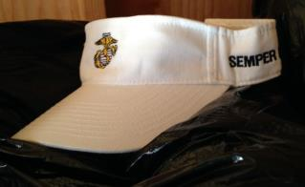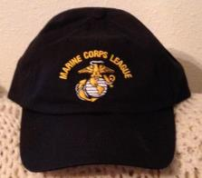
-------------------------------------------------------------------------------

DETACHMENT COINS / CHIPS Lots of them still available
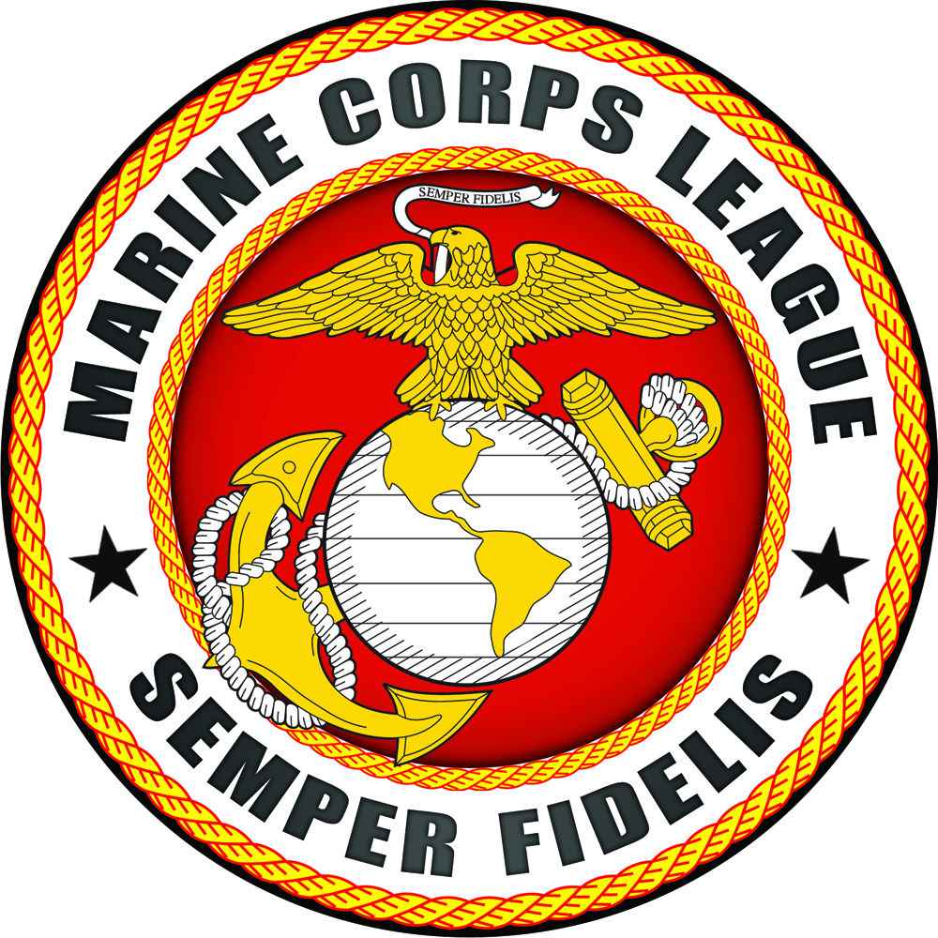

The new supply of detachment challenge coins / chips are in. They are being sold for $1.50 each which off-sets the cost of buying them and makes the detachment 45 cents on each one sold. So stock-up (10 for $15.00) while they last. They are available for purchase in-person during the monthly meetings and from the detachment paymaster.
You can carry one on you as your representation of the detachment when “challenged.” You can also give them out to Marines, FMF Corpsmen, and FMF Chaplains as recruiting tools; or as gifts to family, friends, and acquintances who are veterans themselves.
You may notice that the detachment web-page, the detachment newsletter, and detachment correspondence headings utilize this art work since they are unique to our detachment.
-------------------------------------------------------------------------------------------------------------------------------
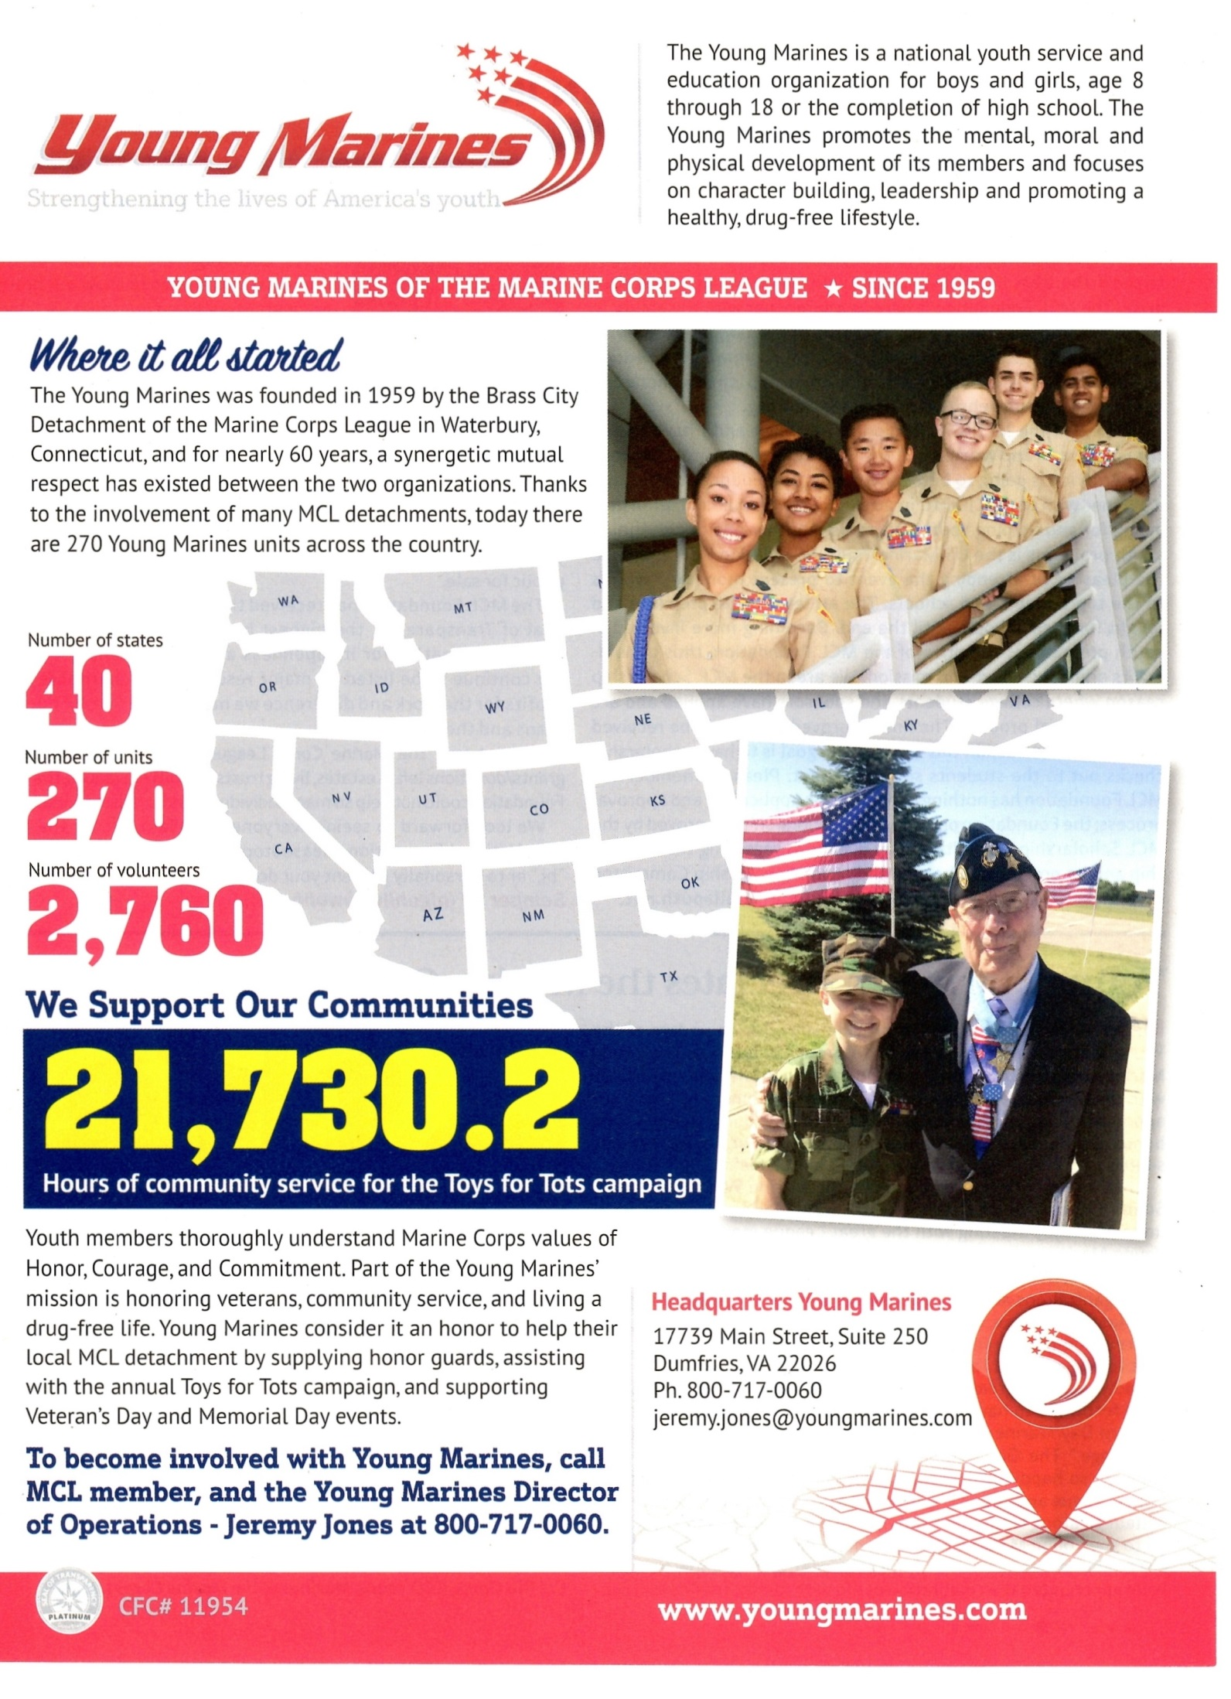
Information Courtesy of the Semper Fi Magazine
-------------------------------------------------------------------------------------------------------------------

EMERALD EMPIRE DETACHMENT # 917 OFFICERS & CONTACT INFORMATION:

Commandant Joseph Lamm Senior Vice-Commandant Paul Grinde
(H) (541) 337-0539 (H) (541) 704 - 0150
Lamm43@gmail.com beavers@epud.net

Junior-Vice Commandant Dan Stombaugh Judge Advocate Peter Bock
(Cell) 503-706-0376 (541) 799-8446
dwstombaugh@msn.com sr32mason@yahoo.com

Adjutant Raymond J. Miller Paymaster Lois J. Price
(H) (541) 689-9456 (541) 741-1772
ray.miller.usmc@gmail.com lostrose7@msn.com

Chaplain Nancy Lukasik Web-Master Eddie Mosteller
(541) 461-1160 (541) 654-5643
nlukasik@comcast.net eddiem3555@gmail.com

Sgt-At-Arms Robert Shirley
rmshirley55@hotmail.com

------------------------------------------------------------------------------------------------------------------------------------------
Springfield BPOE Elks Lodge #2145
1701 Centennial Blvd Springfield, OR 97477
3rd Wednesday of the Month
Dinner @ 1800 hours
Meeting Starts @ 1900 hours

Mailing address:
Emerald Empire Detachment #917
PO Box 70455 Springfield, OR 97475

Detachment E-mail Address:
mcldet917@gmail.com

Detachment Facebook Page:
http://www.facebook.com/pages/Marine-Corps-League-Det-917/214059775343828

Detachment Web Site: www.mcl917.org

Department Web Site: http://www.mcl-oregon.org

National Website: www.mclnational.org

