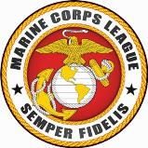
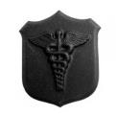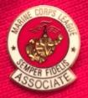

*** January 2018 NEWSLETTER ***

Our next meeting will be on: 17 January 2018
_________________________________________

May 2018 be good to each and every one of you – and hoping you had a very merry Christmas and happy New Year day.

CHAPLAIN / CORPSMAN:

Received a phone call from Joe Halford regarding U.S. Marine Corps Burial / Funeral Honors for his father Donald Halford who passed away the second week of December 2017. Joe informed me that his father Donald was a Vietnam Marine and was receiving Disability benefits. I assisted Joe by putting him in contact with Headquarters Marine Corps to arrange this benefit for his father.

Semper Fi Donald! Another Marine has reported for Duty on Heaven’s Scene.

-------------------------------------------

Received via the detachment website, and detachment web-master Eddie Mosteller, a request for contact from Gary Hammond (past commandant of a Marine Corps League detachment in Georgia – {678-232-9444}) to talk about a Marine in our area. Gary knows the brother of a Korean Marine who is in long tern hospice in the Eugene area. This Marine has two Purple Hearts that he wants to leave to an organization that may utilize one or both in displays to fallen brothers. Gary was going to pass my contact information along to the family. As of this writing I have not received any contact from the family but it may be due to the holidays.
------------------------------------------------------------------------------------

Chuck Lang – will be having surgery this January 4th. So please keep Chuck in your thoughts and prayers. It seems the surgery I reported on at the December meeting was postponed to this new date. You can send Chuck your thoughts at: clang3705@gmail.com or by texting him at: 3602196826

-------------------------------------------------------------------
Joyce Denton – Detachment Chaplain Nancy Lukasik reported that she had talked with Joyce and that Joyce sounded bright and cheerful. Joyce has a grand-daughter living with her now, and Joyce is making plans for the future. Joyce wanted to pass along that Dave had some league shirts and a cover for anyone interested (a red 2x shirt with the name Dave; a black 2x shirt with no name; and a red league cover. Joyce also indicated that she would be selling the house in the future.

----------------------------------------------------------------------------------------------------------------------

Springfield Veteran’s Memorial Plaza Bench Donation in Place

On 20 September 2017, Area 9, Chapter OR-3, Eager Beavers, Women Marines Association President Debbie Barker and Emerald Empire Detachment #917, Marine Corps League Senior Vice-Commandant Paul Grinde met with City of Springfield, Oregon, Community Relations Manager Niel Laudati. Debbie Barker on behave of the Women Marines Association presented the City of Springfield a check for $850.00, and Paul Grinde on behalf of the Marine Corps League Marine Corps League presented the City of Springfield a check for $850.00. Both Marine Corps organizations collaborated on the purchase / donation of a bench for the Springfield Veterans Memorial Plaza.

The bench is in place and the plaque has been attached. The bench is located right in front of the Women Veterans Memorial which was dedicated and placed within the Springfield Veterans Memorial Plaza on 10 November 2017.

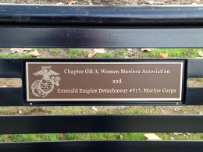

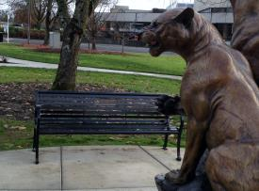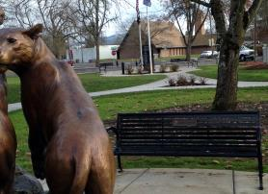
____________________________________________________________________________

New Members & Transfers & Guests

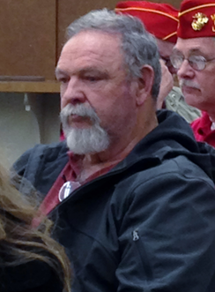
Ronald Sharrah – was a guest at the detachment monthly meeting in December, and subsequently filled out a membership application. Ronald served from 1968-1972 as a 0311 (Infantry), and spent about 1 ½ years in Vietnam. Please introduce yourselves to Ronald and Welcome Him Aboard.

------------------------------------------------------------------------------------
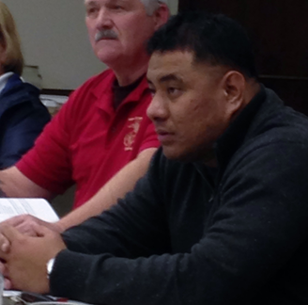

Staff Sergeant Sytafine – was a guest at the December monthly meeting of the detachment. SSgt “S” as it seems everyone calls him was the Toys for Tots coordinator this year.

--------------------------------------------------------------------------

We also had a visit from Steve Robbins who is the new Elks Lodge Chef who provided the Prime Rib dinner menu during the dinner social hour gathering. It appeared that the majority felt the dinner was a success.

If you have dinner ideas that you would like to see in the future we can coordinate contact with our detachment members who are also Elks Lodge members who oversee the kitchen.

----------------------------------------------------------------------------------------------------------------------

Ray Miller, SSgt “S”, and Thad Lukasik gave a report regarding the Toys for Tots 2017 distribution.

For the 1st time Toys for Tots conducted a distribution in Florence, Oregon. Thad & Nancy Lukasik, Eddie & Jeanne Mosteller, the Coast Guard, the police, the fire department and the United States Marines conducted the distribution to 101 families and 228 kids. They also left toys with the fire department for distribution to additional families / kids.

The Oakridge, Oregon distribution had just occurred prior to the meeting so the numbers were not yet available for that activity. Figures will follow at a later date.

The Springfield, Oregon distribution was another big success. Distributions were made to 1,478 families and 3,372 kids. Ray Miller reported that since they started tracking the figures in 2015 that the 2017 distribution has increased 122.1% for families, and 128% for kids.

Toys were also given to the organization Head Start for additional distributions to families/kids.

To all those who participated to make toys for tots 2017 a successful effort – you did an outstanding job!!!!!!

---------------------------------------------------------------------------------------------------------------------

DETACHMENT CHALLENGE COINS / CHIPS ARE IN
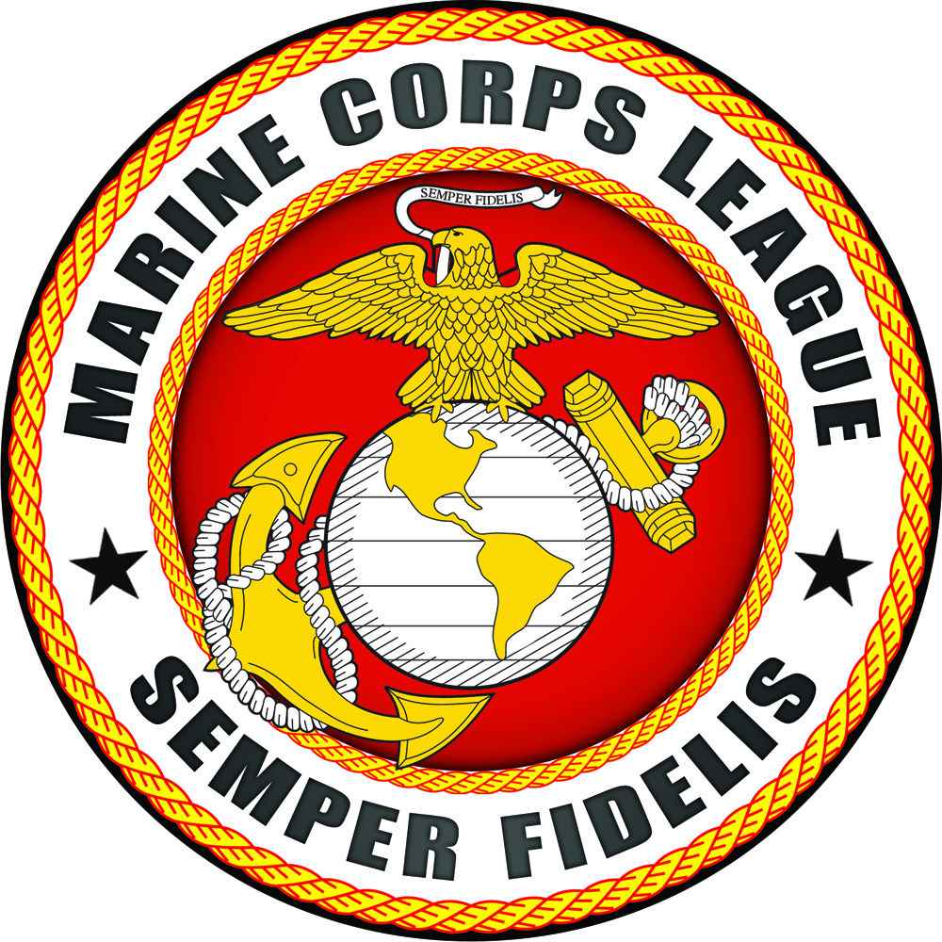

The new supply of detachment challenge coins / chips are in. They are being sold for $1.50 each which off-sets the cost of buying them and makes the detachment 45 cents on each one sold. So stock-up (10 for $15.00) while they last. They are available for purchase in-person during the monthly meetings and from the detachment paymaster.
You can carry one on you as your representation of the detachment when “challenged.” You can also give them out to Marines, FMF Corpsmen, and FMF Chaplains as recruiting tools; or as gifts to family, friends, and acquintances who are veterans themselves.
You may notice that the detachment web-page, the detachment newsletter, and detachment correspondence headings utilize this art work since they are unique to our detachment.

-------------------------------------------------------------------------------------------------------------

Detachment member Ronald Cooper, Sr. (also our Vet’s Court representative) reported that Vet’s Court has been busy with conferences, mentor meetings, and a luncheon (85-90 participants) for those involved in Vet’s Court. He also shared that two new mentors were coming on board soon, and that the new mentor chief has a degree in Psychology. There are 2 judges (1 primary and 1 to cover) who cover Vet’s Court. The completion rate is currently at 96%.

Ronald has also been working with the Legacy Group that is transforming the old sheriff’s work camp into a treatment program for veterans. Ronald has helped to obtain flag poles, and is working on obtaining flags to represent all the branches of the Armed Forces of the United States of America.

There will be no Vet’s Court for January 18th, 2018, as the participants will be conducting a work party at the Legacy Group camp.

The next graduation for Vet’s Court will be toward the end of January 2018.
-------------------------------------------------------------------------------------------------------------------------------------------

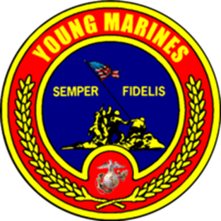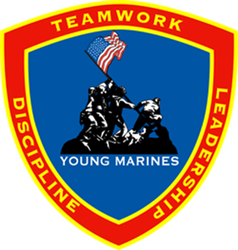
The Emerald Empire Young Marines participated in the Springfield Christmas Parade. The Young Marines were paired up with a Marine during the parade and collected toys and handed out candy & souvenirs.
-------------------------------------------------------------------------------------------------------------------------------------------

FUTURE EVENTS & DATES:

9, 10, 11 February 2018 - 2018 Mid-Winter Conference, Brookings, Oregon

-------------------------------------------------------------------------------------------------------------------------------
GOOD OF THE LEAGUE ANNOUNCEMENTS
- The Detachment Post office Box payment for the next year has been made for $76.00. Lois Price who paid it has been reimbursed her cost.
- Detachment Sergeant of Arms Robert Shirley reported that there is an interesting museum in the blue River, Oregon area for those who enjoy military and native American history:

U.S. Cavalry and American Indian Museum
91160 Yeager Road, Blue River, Oregon 97413; call ahead for dates & hours: (602)619-9599

---------------------------------------------------------------------------------------------------------------------------------------------------------

Eagle, globe, anchor & “semper Fi” White Sun visors and Black Marine Corps League hats – FOR SALE - $5.00 each – What a Deal
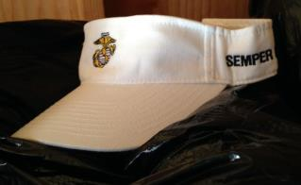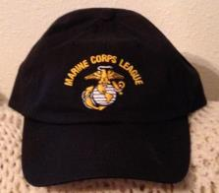
-------------------------------------------------------------------------------
EMERALD EMPIRE DETACHMENT # 917 OFFICERS & CONTACT INFORMATION:

Commandant Joseph Lamm Senior Vice-Commandant Paul Grinde
(H) (541) 337-0539 (H) (541) 895-5735
Lamm43@gmail.com beavers@epud.net

Junior-Vice Commandant Dan Stombaugh Judge Advocate Peter Bock
(Cell) 503-706-0376 (541) 799-8446
dwstombaugh@msn.com sr32mason@yahoo.com

Adjutant Raymond J. Miller Paymaster Lois J. Price
(H) (541) 689-9456 (541) 741-1772
ray.miller.usmc@gmail.com lostrose7@msn.com

Chaplain Nancy Lukasik Web-Master Eddie Mosteller
(541) 461-1160 (541) 654-5643
nlukasik@comcast.net eddiem3555@gmail.com

Sgt-At-Arms Robert Shirley
rmshirley55@hotmail.com

------------------------------------------------------------------------------------------------------------------------------------------
Springfield BPOE Elks Lodge #2145
1701 Centennial Blvd Springfield, OR 97477
3rd Wednesday of the Month
Dinner @ 1800 hours
Meeting Starts @ 1900 hours

Mailing address:
Emerald Empire Detachment #917
PO Box 70455 Springfield, OR 97475

Detachment E-mail Address:
mcldet917@gmail.com

Detachment Facebook Page:
http://www.facebook.com/pages/Marine-Corps-League-Det-917/214059775343828

Detachment Web Site: www.mcl917.org

Department Web Site: http://mcl-department-of-oregon.org/

National Website: www.mclnational.org

